Correction :
How well can you tell the time ? Savez vous bien dire l’heure ?
A chì puntu sapete dì l’ora ? 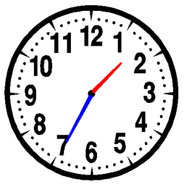

Write on your board the following hours in digital time :
It’s ten to three am = 02:50
It ‘s a quarter to nine pm =20:45
It’s half past two am =02:30
It’s twenty-five to nine pm =20:35
It’s five past one pm =13:05
It’s a quarter past seven pm=19:15
It’s eleven o’clock pm =23:00

Write in analog and digital time the following hours (so 2 ways !!!)

22:15= it’s (a) quarter past ten pm // It’s twenty-two fifteen

13:40 = It’s twenty to two pm // It’s thirteen forty

08:10= It’s ten past eight am // it’s eight ten

14:50=it’s ten to three pm // it’s fourteen fifty

02:02= It’s two past two am // it’s two oh two ( le zero se lit “ oh” )

20:30= it’s half past eight pm // it’s twenty thirty

